Damro Furniture
TOTAL : 70 MARKS
HTML-CSS : 40 MARKS
JAVASCRIPT : 30 MARKS
Damro Furniture is one of the new sofa manufacturing companies in the city. As part of their business process, they also have a delivery service. Customers who order the sofa, can have their order delivered within 10 days. Damro Furniture management gets numerous orders to deliver and processing them manually takes enormous time. Help them to develop a web page to calculate the total sofa cost on a booking, which includes the actual sofa cost, GST and delivery charges. On submitting the details, the message has to be displayed on the same page as shown in the given screenshots.

Plain Web page :
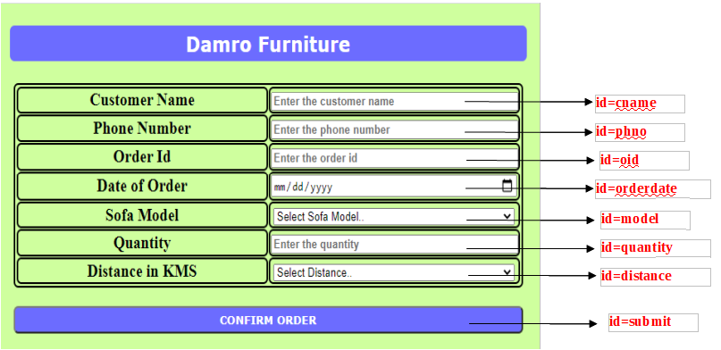
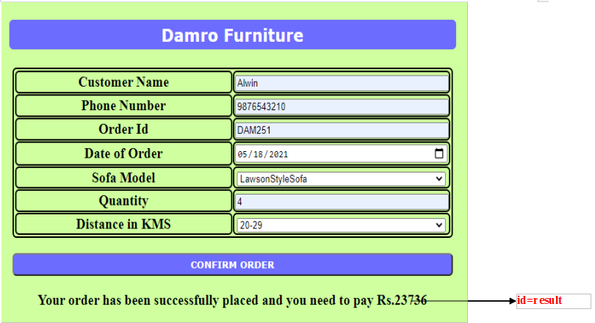
After giving all relevant details and clicking on CONFIRM ORDER button :

Use the Label Name and the Component Id as given. All the necessary attributes for the Components should be given. The Component Id should be specified for each HTML Component. If the Component Id is not provided for an HTML component, marks will not be provided for that component. All Tags, Elements and Attributes should conform to HTML5 Standards. All the fields are mandatory.
Provide the details as given in the table below.
Req. # | Req. Name | Req. Description
1 | Design an HTML page for “Damro Furniture” application | Note: The text highlighted in bold in the Description needs to be implemented in the code to complete the web page design.
  Label Name | Component Id  (Specify it for the “id” attribute) | Description
  Customer Name | cname | To enter the name of the customer.  Design Constraints:  - The text “Enter the customer name” should appear by default.  - It should be mandatory.  - Use type=“text”
  Phone Number | phno | To enter the phone number of the customer.  Design Constraints:  - The text “Enter the phone number” should appear by default.  - Use type=“text”  - It should be mandatory.
  Order Id | oid | To enter the order id.  Design Constraints:  - The text “Enter the order id” should appear by default.  - Use type=“text” with pattern attribute for accepting a 3-digit number following "DAM"
  Date of Order | orderdate | To enter the order date.  Design Constraints:  - Use type=“date”
  Sofa Model | model | To select the sofa model.  Design Constraints  Use the drop down box with “Select Sofa Model..”, “SectionalSofa”, “LawsonStyleSofa” and “ContemporarySofa” as the options and its values.
  Quantity | quantity | To enter the quantity.  Design Constraints:  - The text “Enter the quantity” should appear by default.  - Use type=“text”  - It should be mandatory.
  Distance in KMS | distance | To select the distance.  Design Constraints  Use the drop down box with “Select Distance..”, “10-19”, “20-29” and “30 above” as the options and its values.
   | submit | Submit Button to submit the form  Design Constraints  - The input type should be “submit”.  - The value should be “CONFIRM ORDER”
2 | Apply the mentioned styles using CSS to the components | STYLING WITH ELEMENT SELECTORS  - HEADING should be specified using <h3> tag.  Its color must be #FFFFFF and the background-color must be #6666FF.  The margins: margin-left and margin-right must be auto.  The text-align must be center and width 50%.  The font-family of the text must be Verdana.  The padding and border-radius must be 5px and 6px respectively.  - TABLE, tr and td must be styled with width as 50%.  The margins: margin-left and margin-right must be auto.  The border-spacing and border-radius must be 1px and 6px respectively.  Its color must be #000000 and the background-color must be transparent.  The padding must be 1px.  STYLING WITH ID SELECTOR  - SUBMIT component must be styled using its id as in :  Its color must be #FFFFFF and the background-color must be #6666FF.  The margins: margin-left and margin-right must be auto.  The padding must be 5px and the width must be 50%.  The font-family of the text must be Verdana and font-weight must be bold.  The border-radius must be 6px.  - RESULT component must be styled using its id as in:  Its color must be #000000 and the font-size must be 20px.  Note: Fill in the style tag so as to have the given styles applied to the components. (Do not use Inline CSS and shorthand styling)
3 | Use JavaScript for displaying the bill amount details. | Use JavaScript for displaying the bill amount details:  When the valid values are entered and the “CONFIRM ORDER” button is clicked, the bill amount should be displayed as follows:  “Your order has been successfully placed and you need to pay Rs. totalSofaCost”  in a div tag with id as “result”.  Assumption:  If the distance is less than 10 km or if no sofa model selection is made, then the cost of delivery is Rs. 0  Formula:  sofaCost= quantity* cost per sofa  gst= sofaCost*GST percentage/100  totalSofaCost= sofaCost+gst+deliveryCost  Example: If a customer places order for 4 “Lawson style sofa” and requests for delivery at a distance within “20-29” kms then,  sofaCost = Rs. 21996  gstTax = Rs. 1539.72  deliveryCost = Rs. 200  totalSofaCost = Rs. 23736  Note:  - Use the getElementById() function to retrieve the values.  - Use Math.round() upon the final result to get a rounded value.  - In Javascript, Please do not use “let”. Instead, use “var”.
  Sofa Model | Cost per sofa | GST percentage
  SectionalSofa | Rs. 4999 | 7%
  LawsonStyleSofa | Rs. 5499 | 7%
  ContemporarySofa | Rs. 3699 | 7%
  Distance | Delivery cost
  10-19 | Rs. 100
  20-29 | Rs. 200
  30 above | Rs. 350
4 | form Tag with attribute onsubmit | The form Tag is already given in the code template. Do not change the code template and do the coding as per the requirements and specification.  Make sure that the onsubmit attribute in the form tag invokes the JavaScript function like "return display()". Also ensure that the “return false;” statement should be the last line of the JavaScript function “display()”.

